**Unvelling Market insights: Analysing Spending Behaviour and Identifying Opportunities for Growth**.

1. **Introduction:**
   1. **Overview:**

This project is about the Unvelling Market Insights. Here we have analysed spending behaviour and identifying opportunities for growth.

* 1. **Purpose:**

This Project aims to analyze customer spending behaviour and identify opportunities for growth by leveraging data analytics and data-driven decision-making.

1. **Problem Definition & Design Thinking:**
   1. **Empathy Map:**

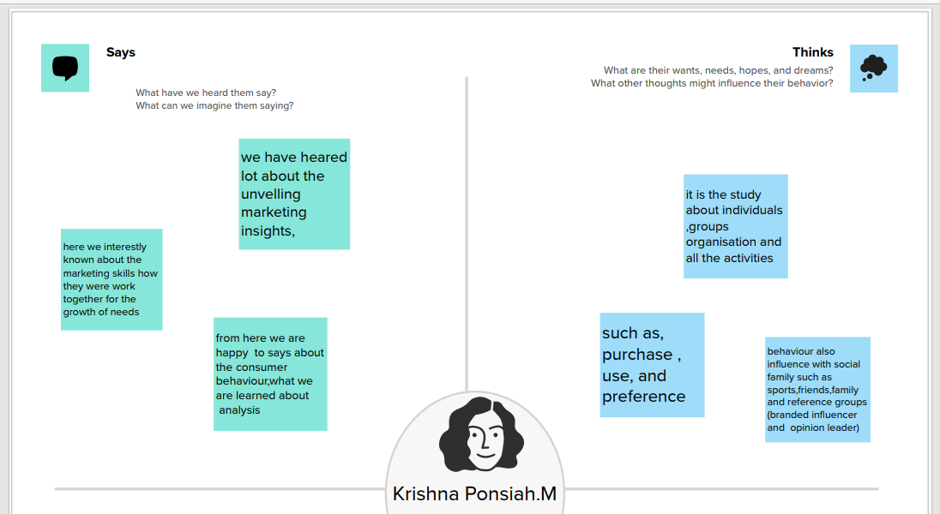

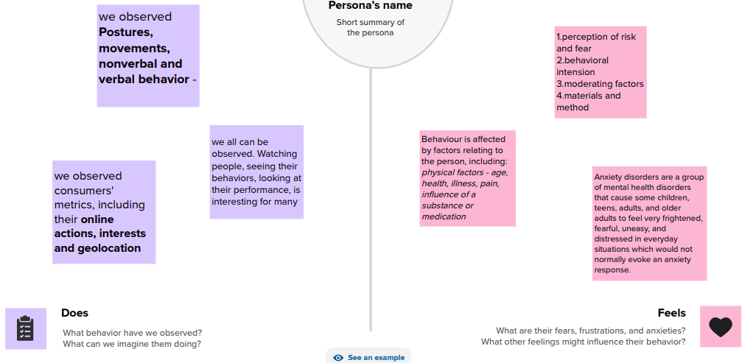

2.2 Ideation and Brainstorming Map:

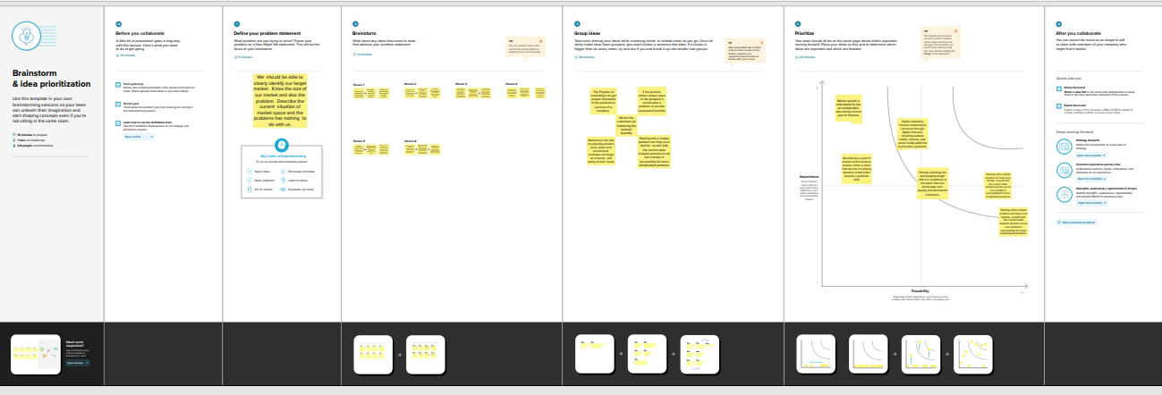

1. **Result:**

**Dashboard:**

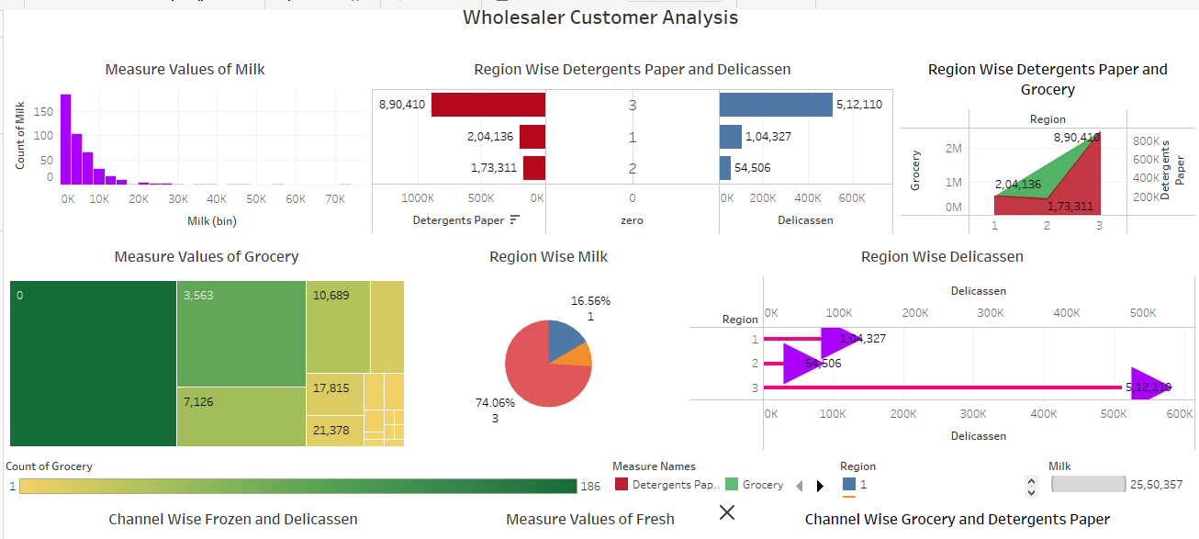

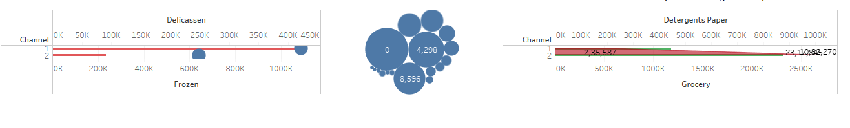**Story:**

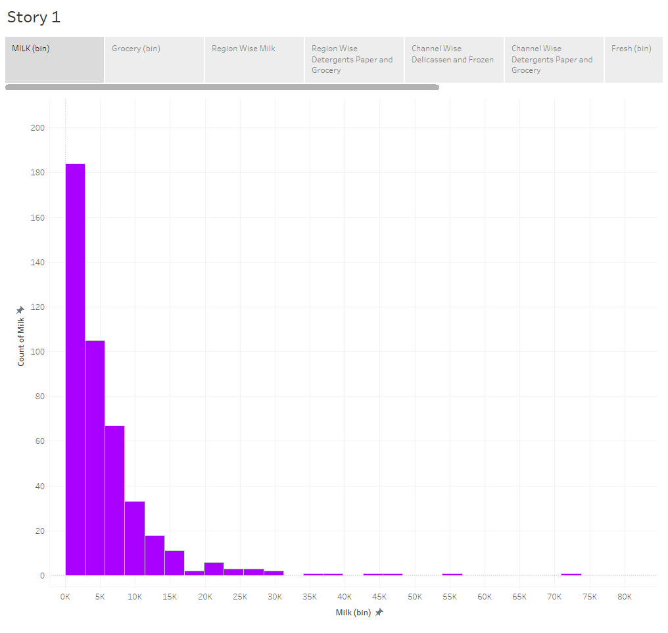

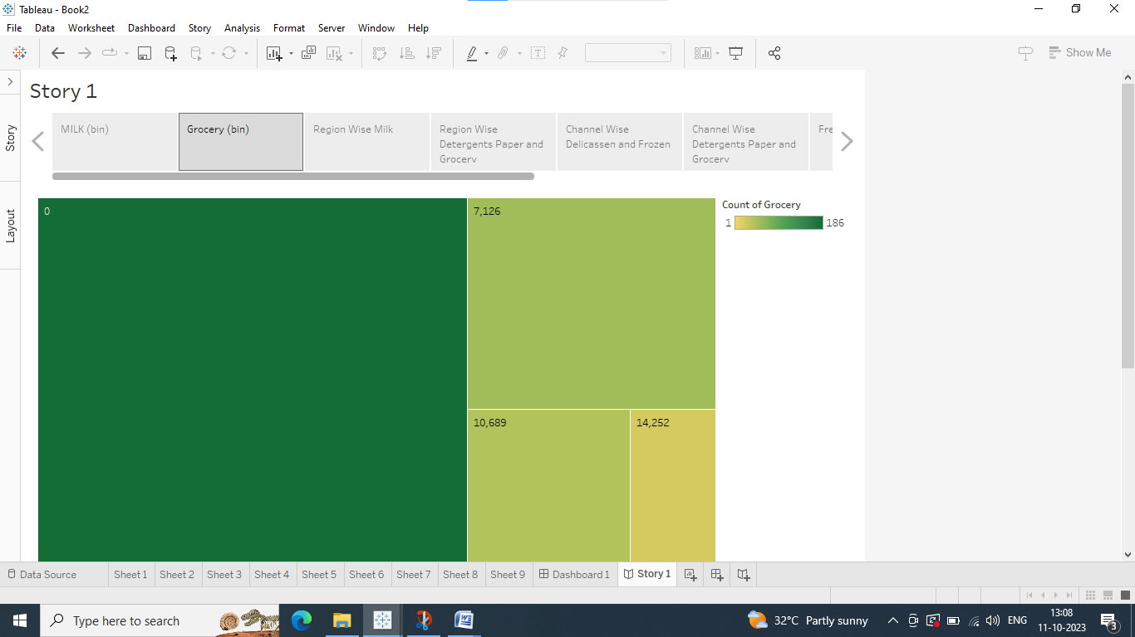

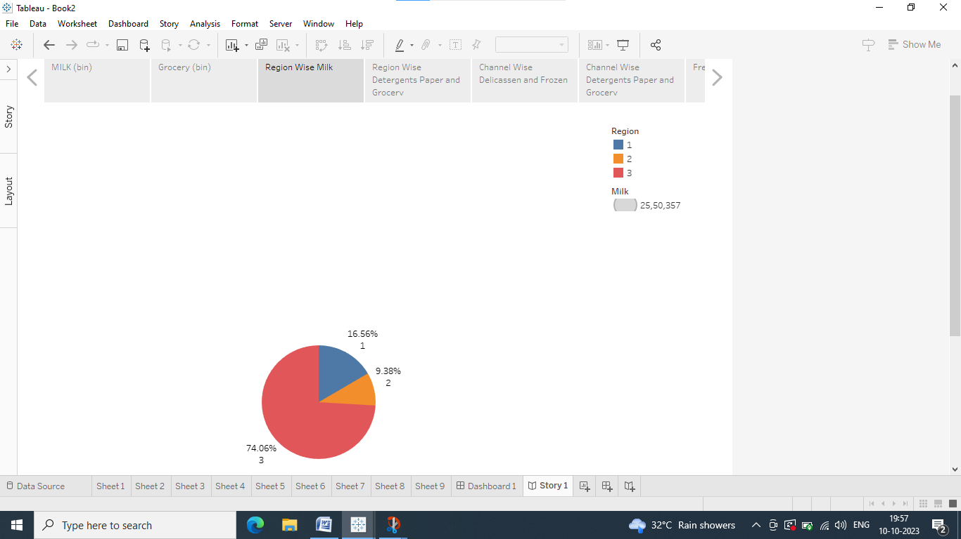

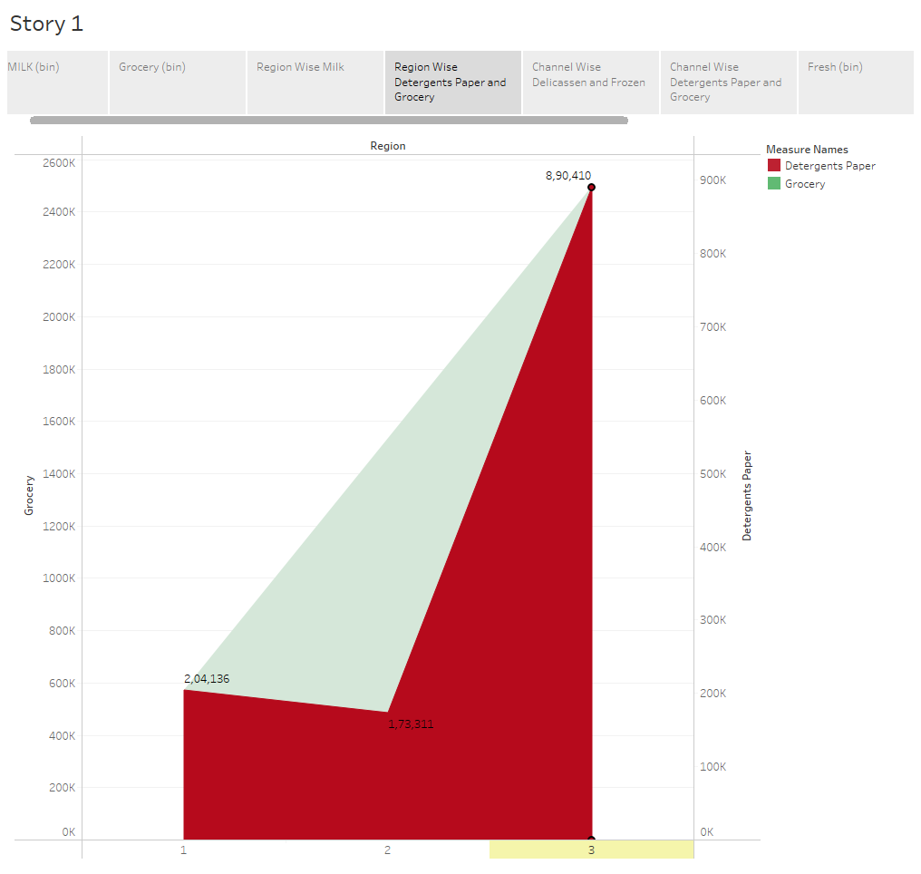

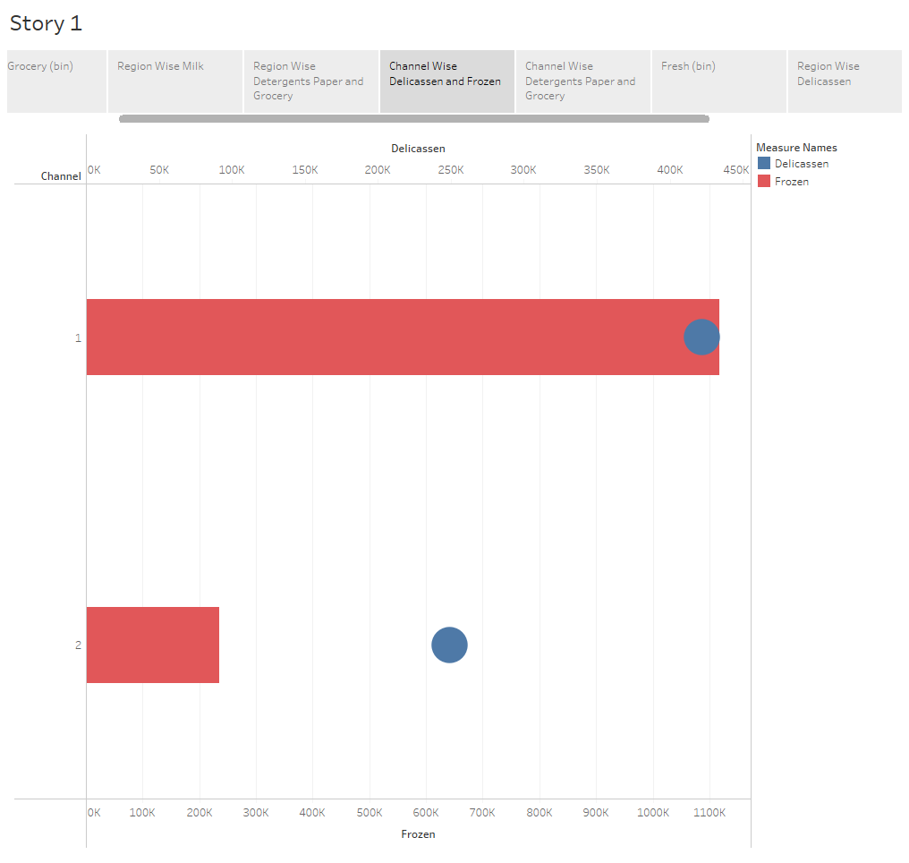

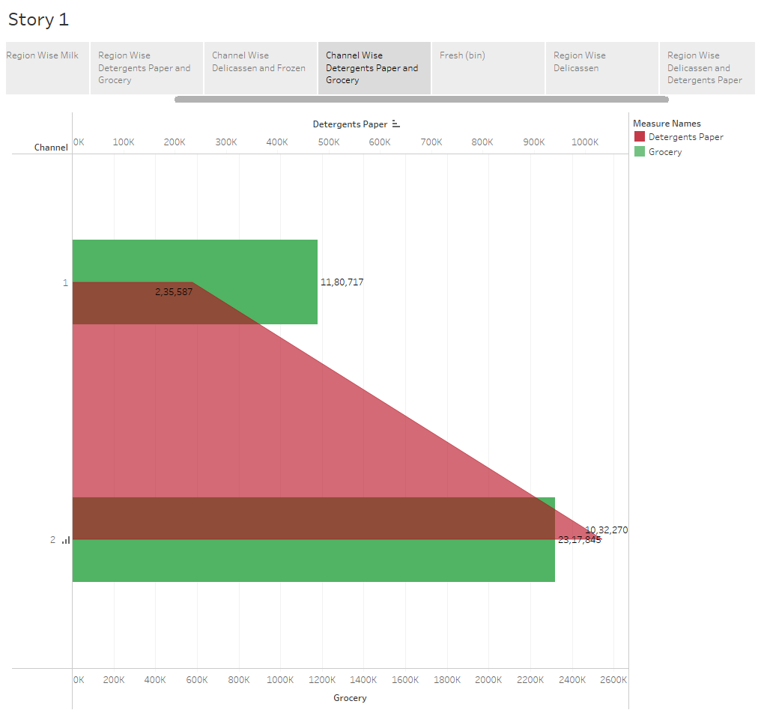

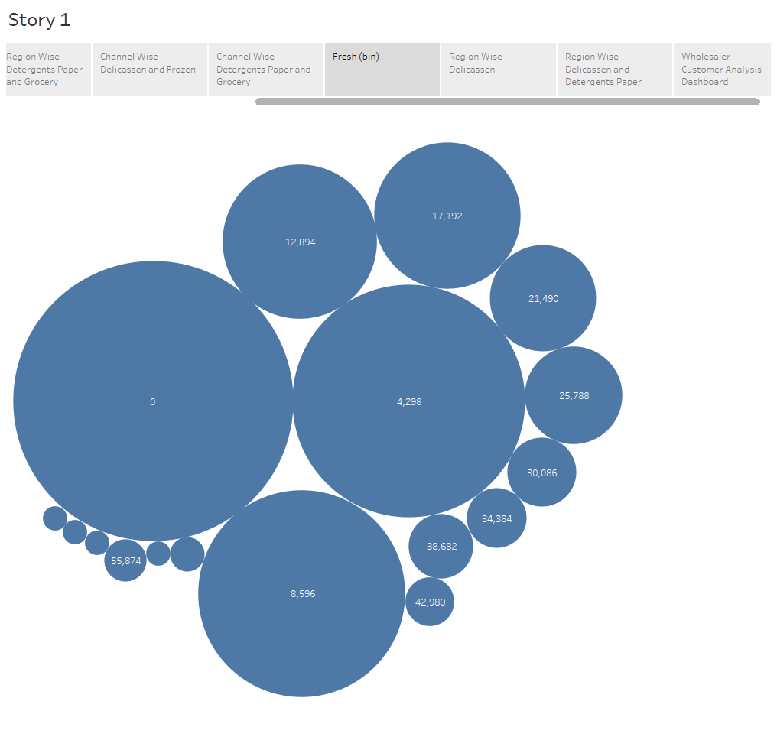

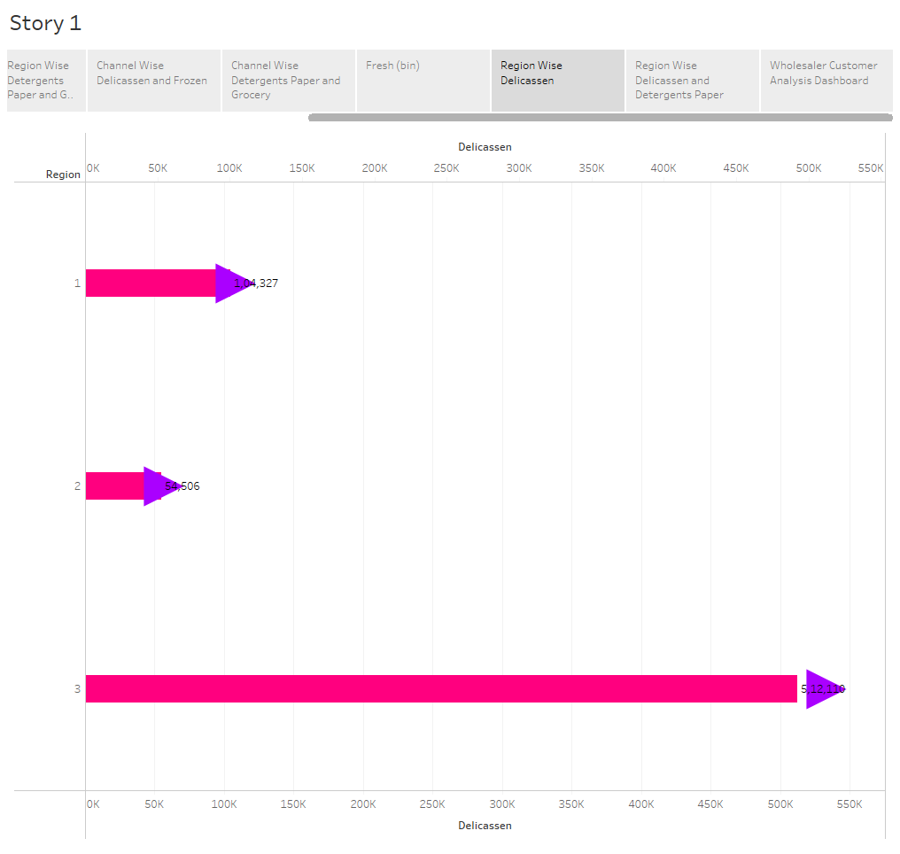

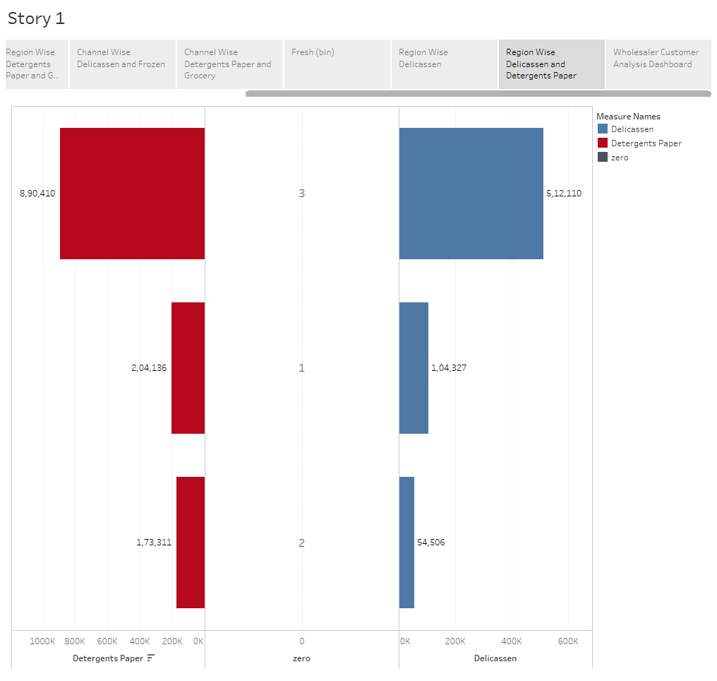

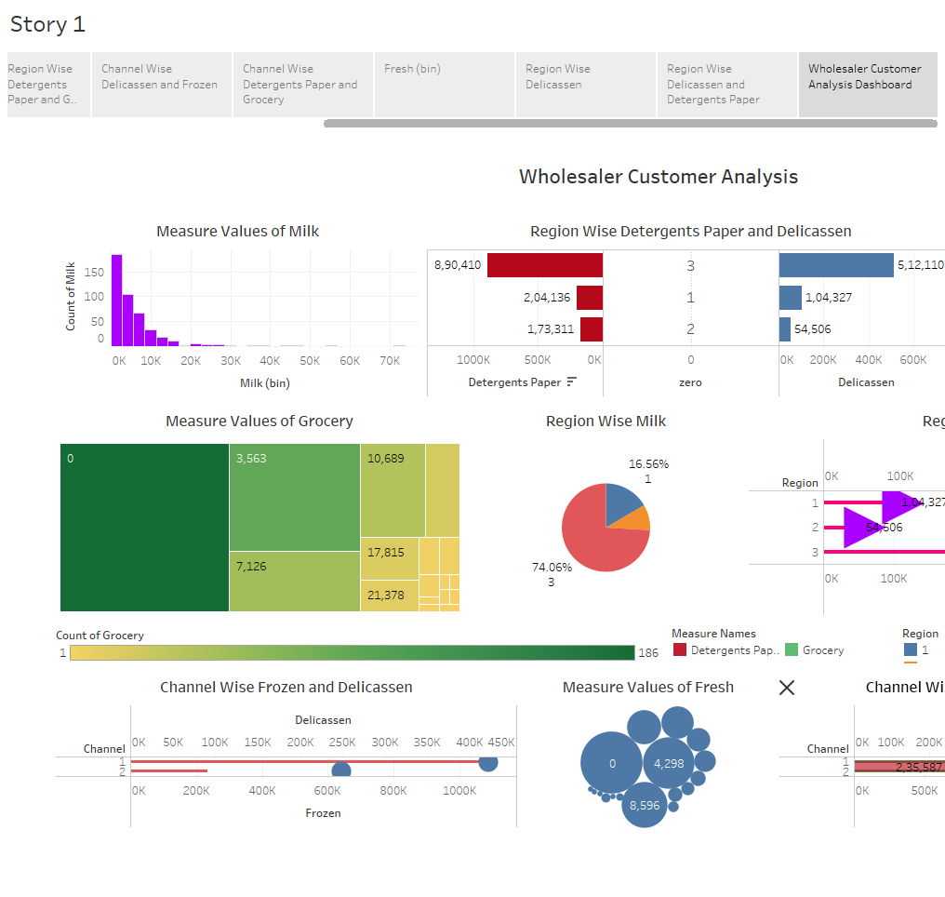

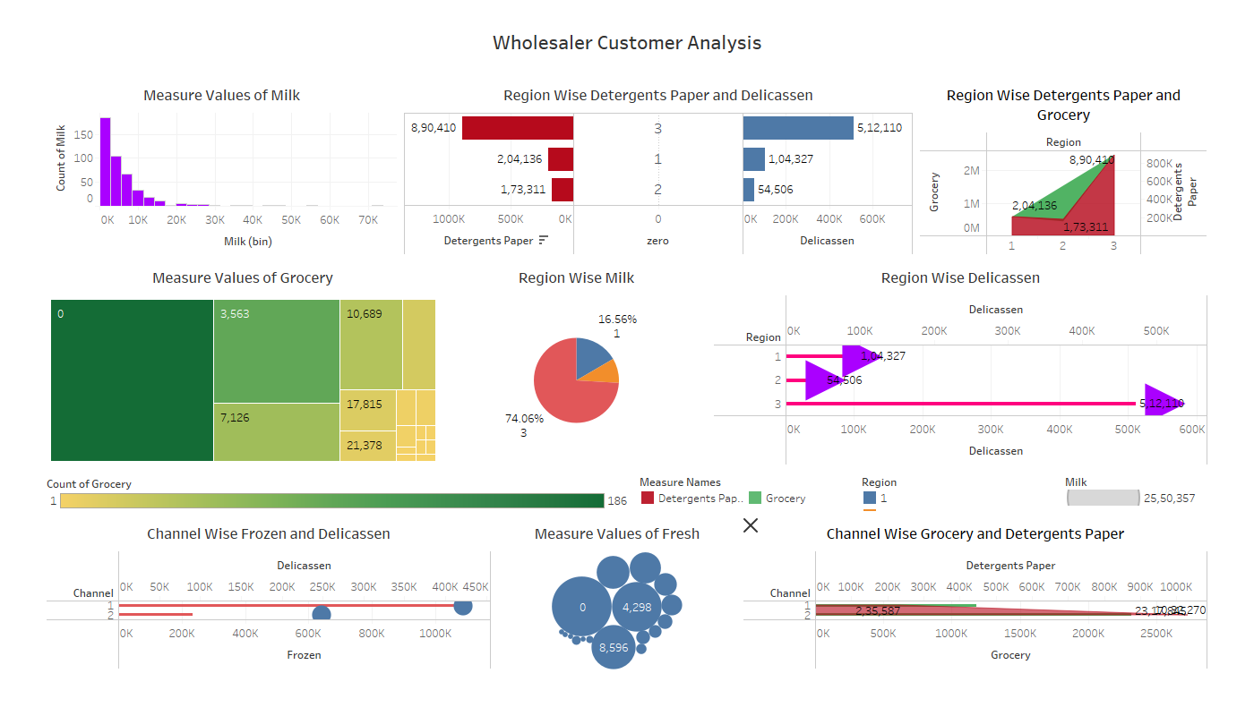

4) ADVANTAGES & DISADVANTAGES:

ADVANTAGES:

This project will be helpful to make well informed choices. Businesses can boost productivity, cut costs, find new opportunities, reduce risks by optimising their strategies and making more informed decisions. It will help businesses to predict the demand. DISADVANTAGES: Fewer dimensions in the dataset. 5)APPLICATIONS: The project can be used to analyse customer behaviour, optimise marketing campaigns, improve supply chain management, enhance product development, predict demand and improve overall business performance.

**Conclusion:**

The spending behaviour of customers is understood by analysing the sales of milk, grocery, detergent paper, frozen & delicatessen across various regions & channels. Frozen sales are the highest and it is followed by grocery and milk. Sales of detergent paper, grocery, delicatessen & milk in region 3 are the highest. Sales of detergent paper & grocery are more in channel 2 than in channel 1. Sales of frozen & delicatessen are more in channel 1 than in channel 2.

7) FUTURE SCOPE:

The data will be analysed by adding extra dimensions such as age group, time period & gender.